TOPIC 6:BACK TRACKING PROBLEM
Program 1: N-Queens Problem Aim:
To place N queens on an N×N chessboard such that no two queens attack each other using backtracking.

Algorithm:
- Start the program.
- Input the number of queens N.
- Create an N×N board initialized with zeros.
- Define a function is_safe() to check column and diagonal safety.
- Place a queen in a column if safe, and move to the next row.
- If all queens are placed, print the solution.
- If placement not possible, backtrack.
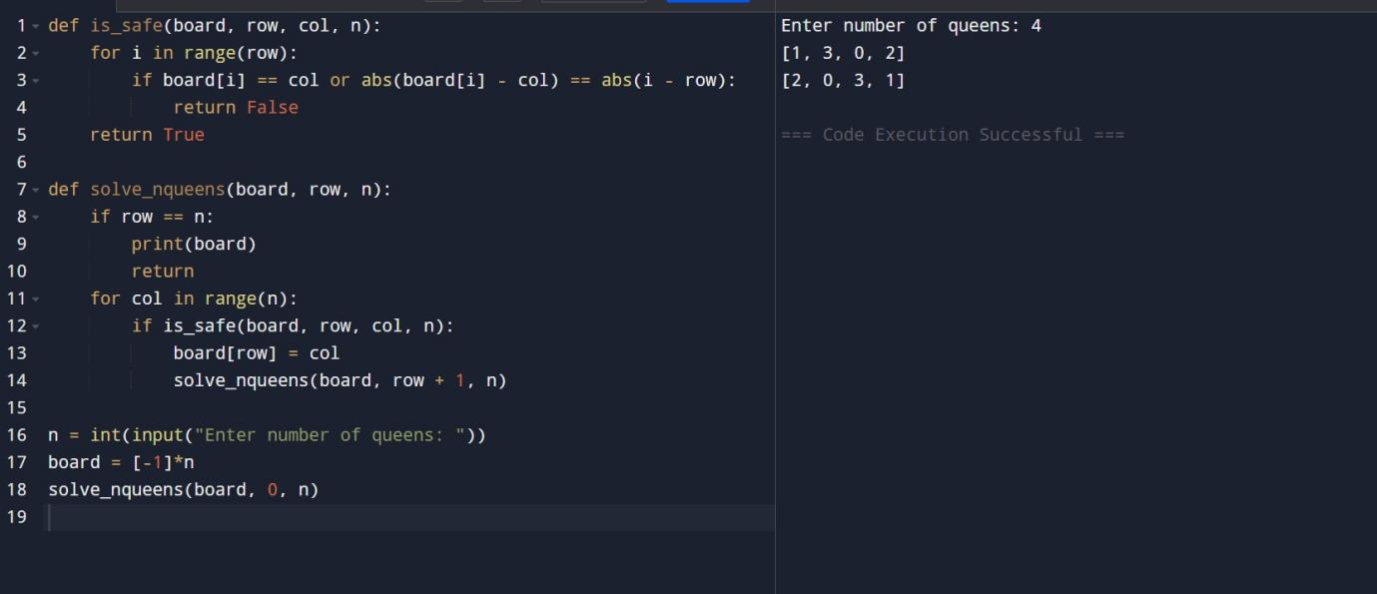
- Stop the program.

Program 2: Generalized N-Queens Aim:
To solve the N-Queens problem for any N value and different board sizes or restrictions.

Algorithm:
- Start the program.
- Input board dimensions and obstacles (if any).
- Initialize the board with zeros or ‘X’ for blocked cells.
- Use a recursive function to place queens safely.

- Check rows, columns, and diagonals before placing.
- If valid configuration found, display it.
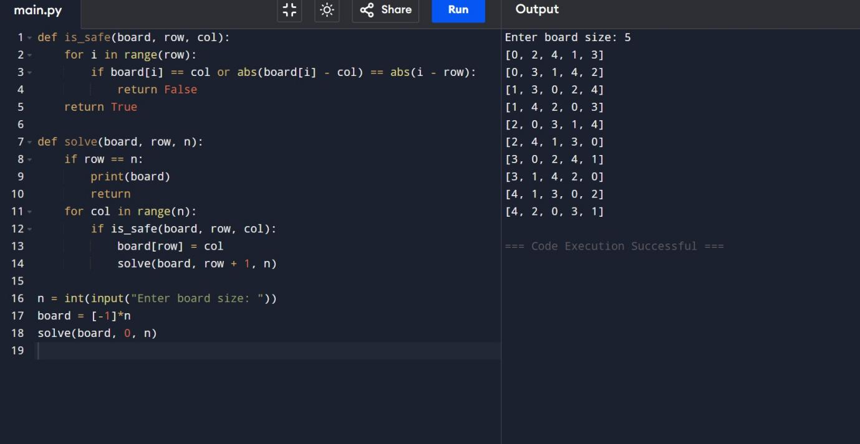
- Stop the program.

Program 3: Sudoku Solver Aim:
To solve a 9×9 Sudoku puzzle using backtracking.

Algorithm:
- Start the program.
- Input the 9×9 Sudoku grid.
- Find the first empty cell.
- Try numbers 1–9 sequentially.
- If the number is valid in row, column, and subgrid, place it.
- Recursively solve for the next cell.
- If no valid number, backtrack.
- Display the solved Sudoku.
- Stop the program.

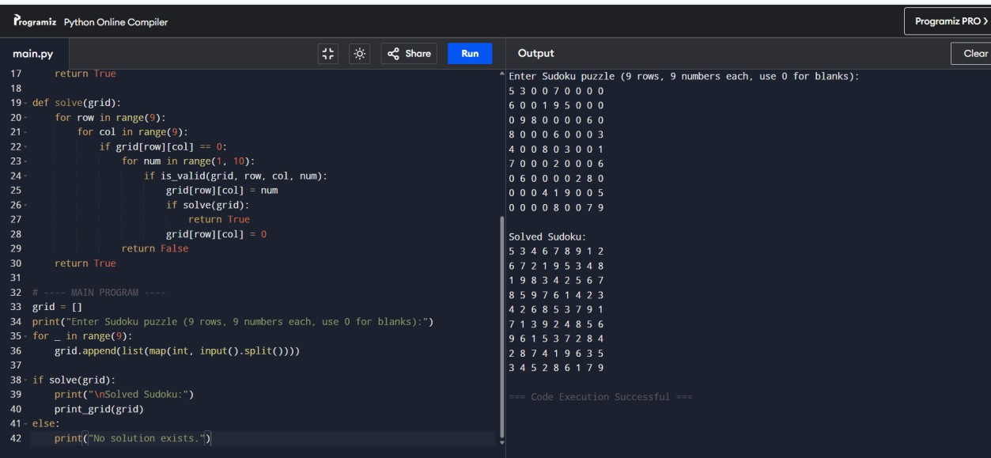
Program 4: Rat in a Maze Aim:
To find all possible paths for a rat to reach the destination using backtracking.

Algorithm:
- Start the program.
- Input the maze as a matrix (1 for open path, 0 for blocked).
- Start from (0,0) position.
- Move in allowed directions (down, right, up, left).
- Mark visited cells to avoid repetition.
- If destination reached, record the path.
- Backtrack to explore new paths.
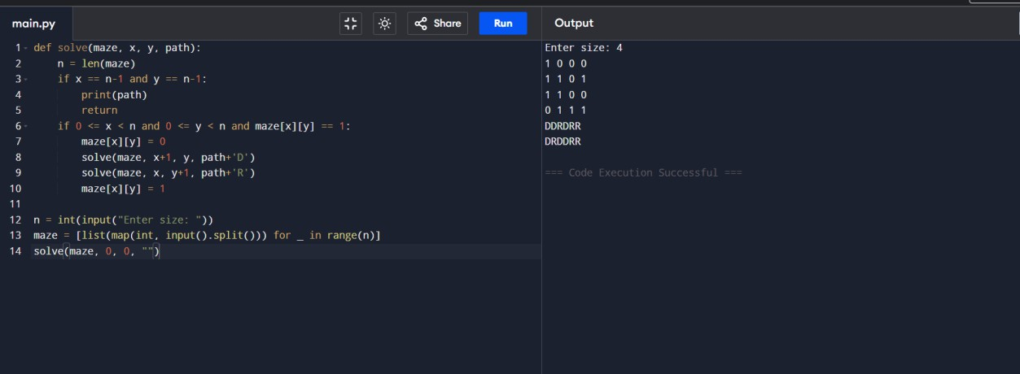
- Stop the program.

Program 5: Knight’s Tour Problem
Aim:
To find a sequence of moves for a knight to visit every cell on a chessboard exactly once.

Algorithm:
- Start the program.
- Input the size of the chessboard (N×N).
- Initialize the board with -1.
- Define all possible knight moves.
- Place the knight at (0,0).
- Recursively try all valid moves.
- If all cells are visited, print the solution.
- If not, backtrack and try another path.
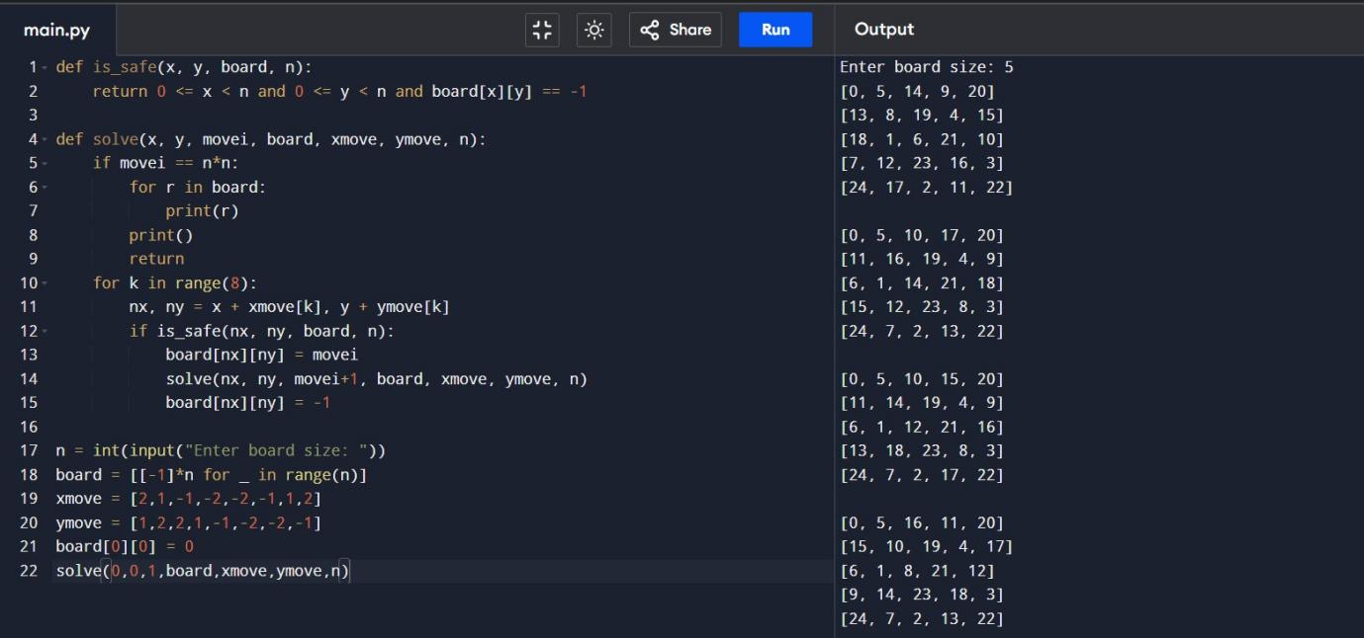
- Stop the program.

